Should I Abandon My Project?

Part 1: A Continuum for Abandoning Projects
Reflect on your project and determine where you are on this continuum.
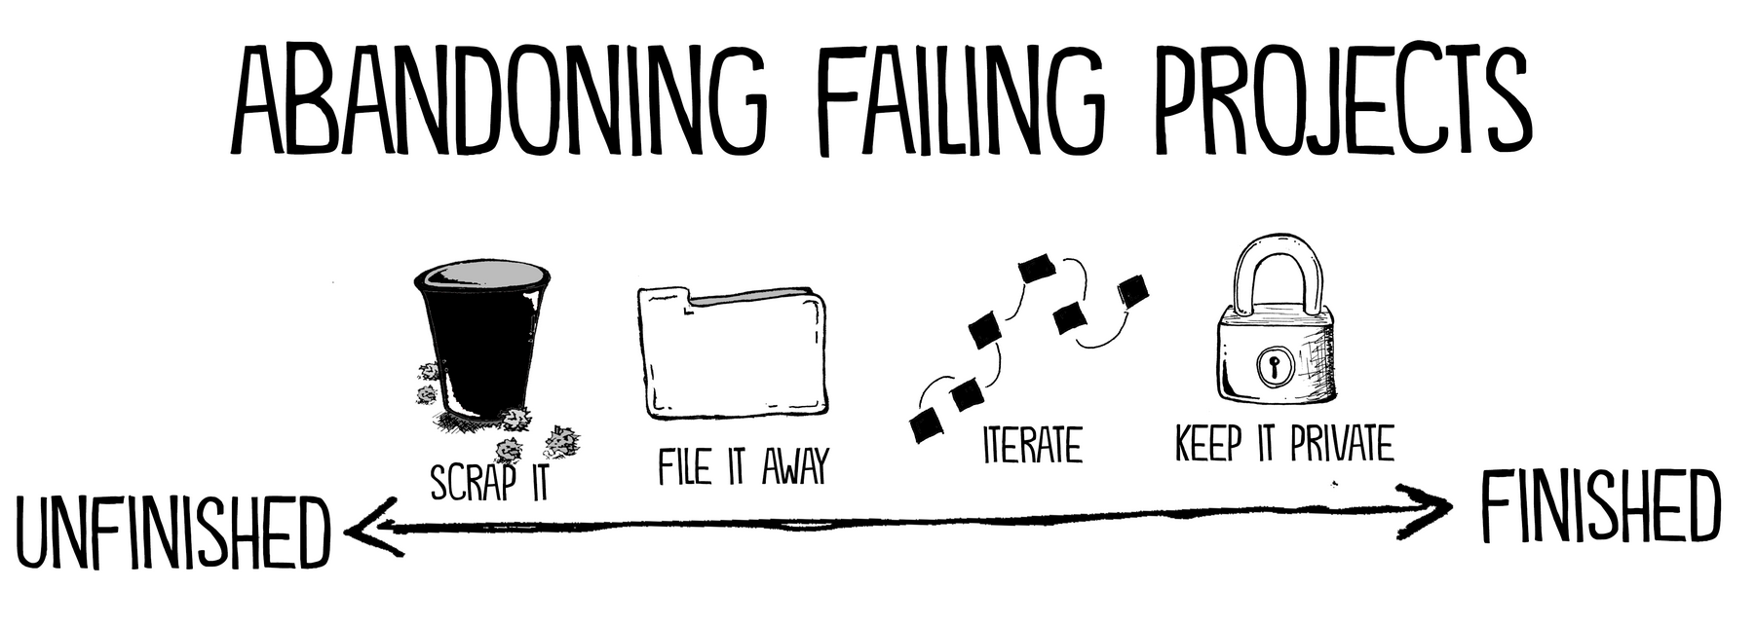
Regardless of the industry or the discipline, there are a few ways we abandon projects. Note that these go on a spectrum from unfinished to finished.
- Scrap It: This is a permanent delete option, where you realize that the project was simply a really bad idea.
- File It Away: Here’s where you feel stuck, so you leave the project unfinished and then potentially pick it up months or even years later.
- Iterate: Here, you don’t shelve the project entirely, but instead, you choose to make massive revisions. You might even mash it up with a different project.
- Keep it private: With this option, you still finish your project but you ultimately choose not to share it with an audience. Here, you’re not abandoning the project so much as abandoning the launch.
Part 2: Reflecting on Your Project
Why do you want to abandon this project?
How far along are you on the project? Are you wanting to quit because you’re not meeting deadlines or because the project really is a failed experiment?
What would happen if you finished it?
Do you want to get rid of it completely, put it on hold, or do a rehaul and revision?
What would you need from your teacher so that you can succeed on this project? (i.e. time or resources)

